1. a, b, d
2. DECIMAL(2,1)
3. 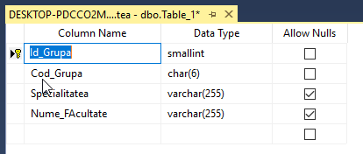Grupe table:

Discipline table:

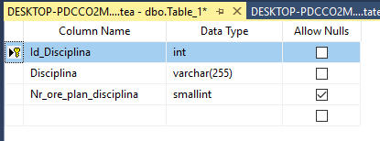

1. 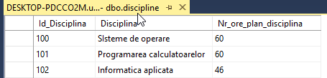Populating *Discipline* table:

Populating *Grupe* table:

